San Jose State University

EE250 (Section 2) Fall 2019 Prof. Kamali

Solution to Problem Set #3

- Problem 4.18
a) 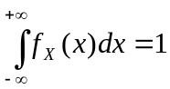
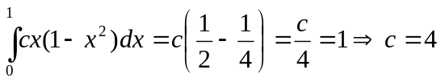

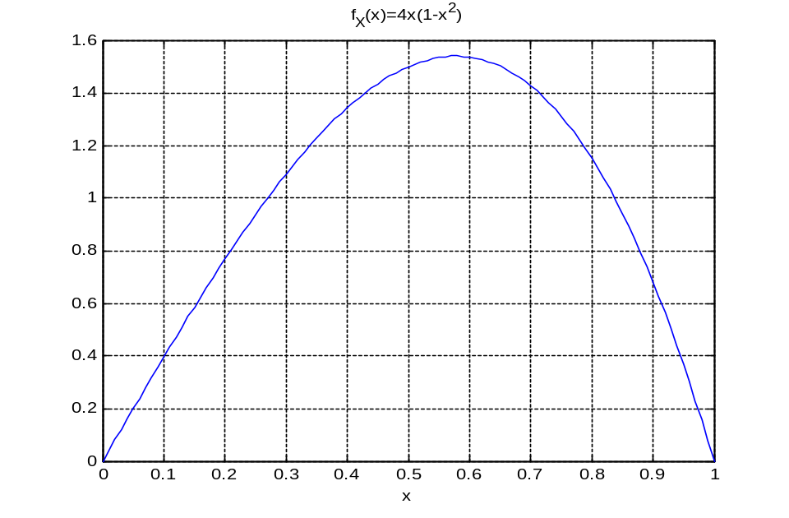
b)
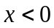, 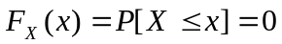
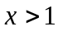, 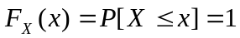
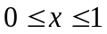, 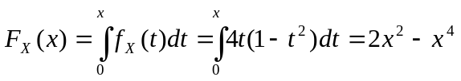
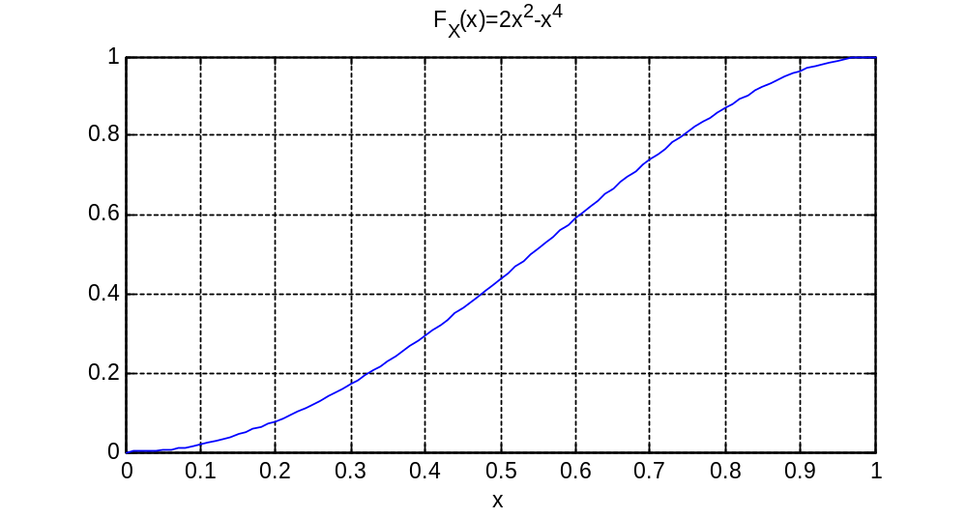

c)

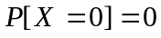 Note that this is a continuous RV.

- Problem 4.26
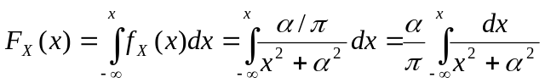

Using the change of variable 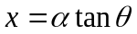, we have

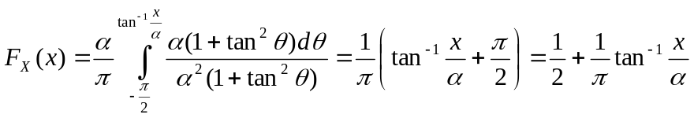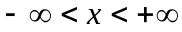

- [Midterm, Fall 2008] The pdf of a random variableis shown in the following figure.

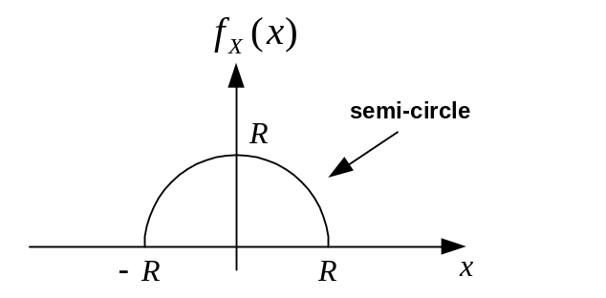

- Find .
- Find 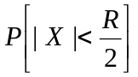.
Note: You must simplify your final answers into a number.

Hint: The change of variable 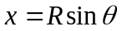may be useful.

Solution:

a) 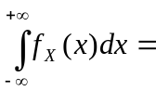Area of half circle = 1

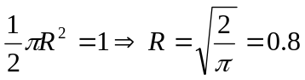

b) 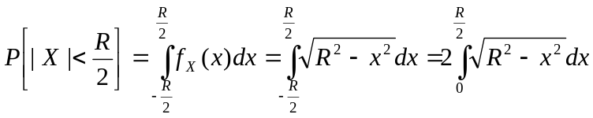

We use the change of variable .

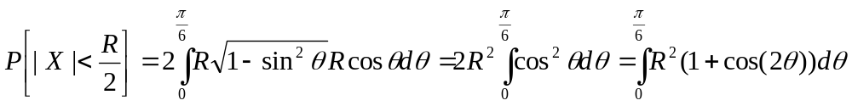

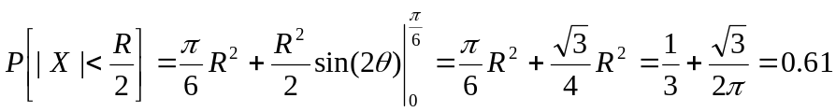

- [Final exam, Fall 2011] Supposeis an exponential random variable with unit mean. Find 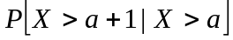 where 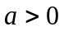.

Solution:
Exponential random variable

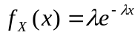for 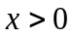 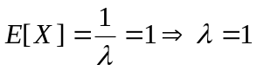
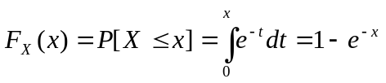

- [Midterm, Spring 2015] Suppose is a continuous random variable with the following pdf.

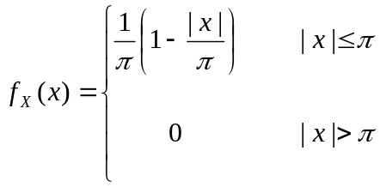

Find 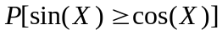 .

Solution:
As the following plot shows if 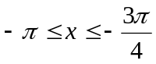or 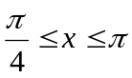, then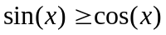.

- [Midterm, Spring 2015] The pdf of a continuous random variable 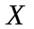 is given as follows.

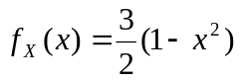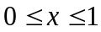

Find 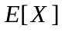 and 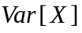.

Solution:

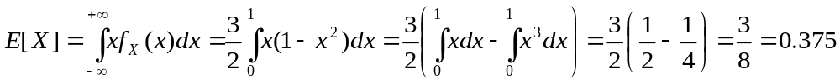

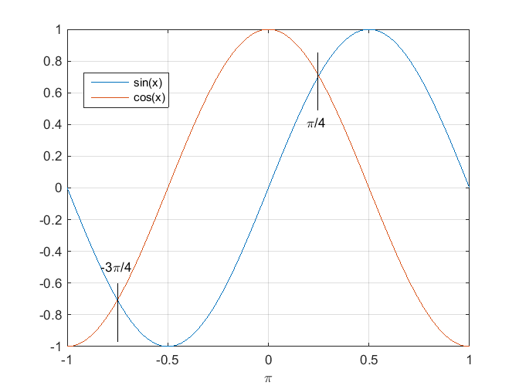
Therefore
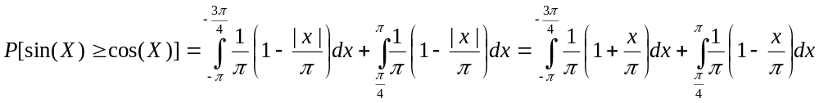
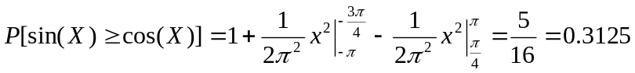

- [Midterm, Spring 2009] The pdf of a continuous random variable is given as follows.

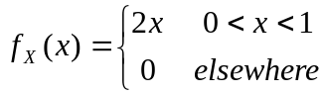

Find such that 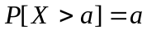.

Solution:

Since can only take on values between 0 and 1, clearly 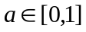 and thus

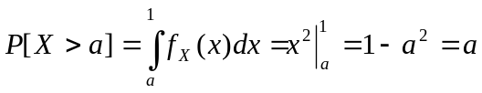
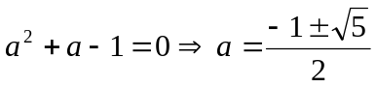

Since , we have 

